A1307, Three Campuses to Cambridge
The Greater Cambridge City Deal is working to improve travel for people across the City Deal region. We welcome your views on these initial ideas for various bus, cycling and walking improvements in and around the A1307. As this project is at an early stage, we are consulting on concepts rather than detailed proposals. Currently just ideas, no specific routes or locations have been identified.
The first stage consultation, which ran from 16 June to 1 August 2016 has now closed. Thank you to all who took the time to respond.

How the ideas were developed
Last year, we engaged with key stakeholders including politicians, employment site representatives and campaign groups to identify transport problems and investigate ideas for potential travel improvements in the A1307 area.
We are keen to create links between major employment sites: Granta Park, Babraham Research Campus and the Cambridge Biomedical Campus. We asked consultants WSP | Parsons Brinckerhoff to look at the A1307 and suggest improvements which could be made to encourage bus use, increase cycling, improve safety and reduce the number of car trips into Cambridge. We also asked the consultants to consider potential environmental improvements.
A range of different ideas were put forward including reopening the Haverhill to Cambridge railway, a bypass for Linton and dualling the A1307. Initial technical work helped to determine and compare the benefits of different ideas and to develop concepts. This included Traffic Surveys on the A1307, the details of which are available to view in the Traffic Surveys Technical Note (pdf, 3.8MB).
The benefits and the costs of these concepts were considered against their ability to meet the objectives of the City Deal programme. The rail and highway dualling concepts were found not to be affordable or justifiable in financial terms, or deliverable within City Deal timescales. For more detail on the these points please see the Rail Viability Technical Note (pdf, 2.1MB) and the Roads Viability Technical Note (pdf, 1MB).
It is important to remember that the concepts presented in this consultation are initial ideas and will only go ahead with public support, and are subject to the decision of elected politicians on the City Deal Executive Board. For further information regarding assessment of these different initial ideas is contained in the Concepts Report (pdf, 8MB).

Sustainable travel
These initial ideas are focused on increasing sustainable travel and aim to reduce congestion and the number of cars coming into Cambridge. Infrastructure that could provide an alternative means of travel is suggested.
Dedicated cycling routes encourage travel by bike and offer a safer alternative to busy roads. Segregated bus links, including bus-only roads and busways, make bus travel quicker, more reliable and a more attractive way to travel. Cycling and walking links could also potentially be used by other modes including equestrians.

Environment
Any bus link on or near the A1307, new Park & Ride site, new cycleways or bus improvements at Linton would have an impact on the local environment. There are important monuments and countryside around the A1307 including Wandlebury Country Park and the Magog Down. Reducing the impact of any transport improvements on the environment will be an important part of developing these initial ideas.
Environmental Constraints in the A1307 area have been mapped. For the Cambridge to Fourwentways area, please see Environmental Constraints Map 1 (pdf, 2.2MB). For a wider view of this area, please see Environmental Constraints Map 1a (pdf, 4.4MB). For the area from Fourwentways to just past Linton, please see the Environmental Constraints Map 2 (pdf, 2.2MB). For the area including Bartlow, Horseheath to Haverhill, please see the Environmental Constraints Map 3 (pdf, 2.2MB).
The above information about the environmental constraints identified so far is also available at local exhibitions. We welcome your input in identifying other environmental issues.

Initial Ideas
The A1307 is one of the main arterial routes into Cambridge from the south east. It links Haverhill, Suffolk to the city and passes close to the major employment sites at Granta Park, the Babraham Research Campus and the Cambridge Biomedical Campus.
Please click to expand the map below which gives an overview of the concepts.
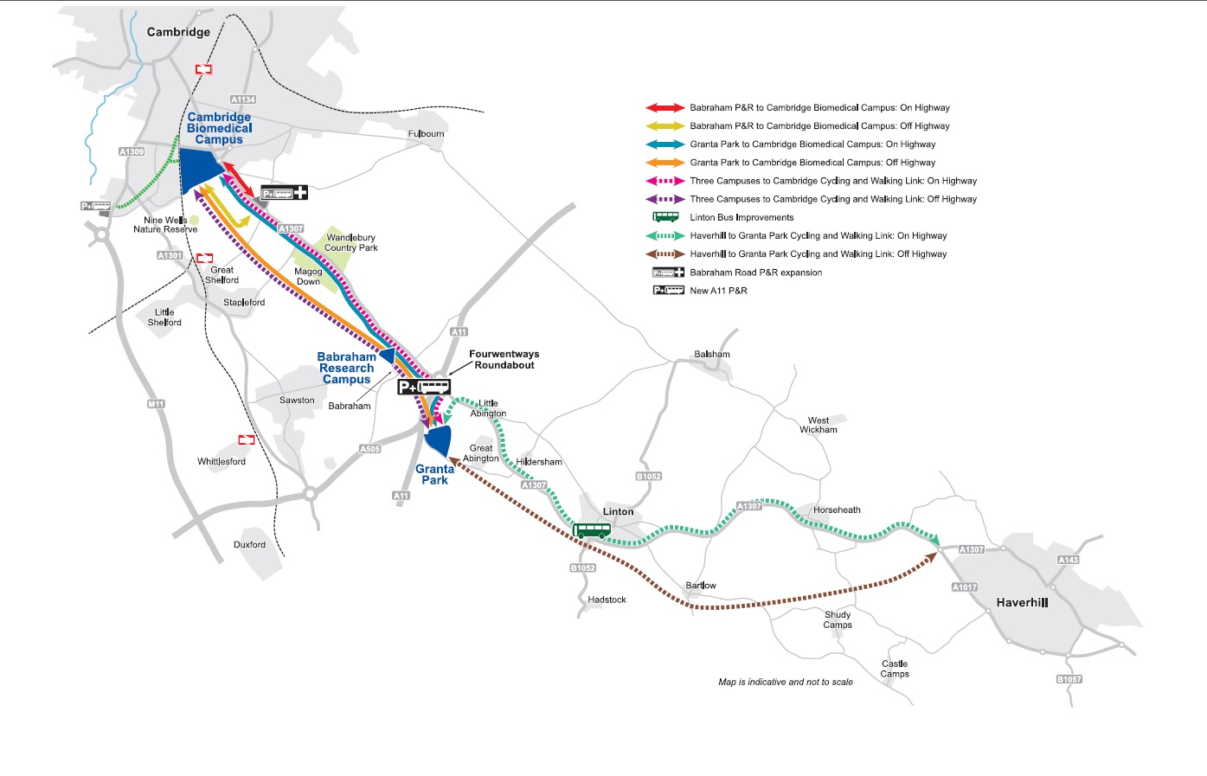
Babraham Road Park and Ride Expansion
A larger Park & Ride site with more parking spaces and improved access. Potential for new facilities such as a business hub and Park & Cycle amenities. Any Park & Ride improvements could connect to new on or off-highway bus links. The indicative cost is approximately £2.5m excluding any land costs.
New A11 Park & Ride
A new additional Park & Ride at the Fourwentways junction. Potential for new facilities such as a business hub and other commercial opportunities e.g. a cafe. We would welcome your views on where a site could be located. Any new park and ride could connect to new bus links. The indicative cost is approximately £12m excluding any land costs.
Babraham Road Park & Ride to Cambridge Biomedical Campus: On Highway
A segregated bus link on the highway. Bus improvements starting south of the Hinton Way/Babraham Road/ Cherry Hinton Road junction to the area around the Addenbrooke’s Hospital. Possibly changing or enlarging the bus station at Addenbrooke’s. Also cycling and walking provision, public space and safety improvements to provide a better gateway to the city.
This new bus link could be combined with Babraham Road park and ride expansion. The indicative cost is approximately £15m.
Babraham Road Park & Ride to Cambridge Biomedical Campus: Off Highway
A segregated bus-only road or busway, off the existing highway, to Addenbrooke’s Hospital and the Biomedical Campus. There would be a dedicated cycling and walking provision alongside any bus link.
This new bus link could be combined with Babraham Road Park & Ride expansion. The indicative cost is approximately £30m excluding any land costs.
Granta Park to Cambridge Biomedical Campus: On Highway
A segregated bus link on the highway, which would link Granta Park, Babraham Research Campus and Cambridge Biomedical Campus via a new A11 Park & Ride. There would be a dedicated cycling and walking provision alongside any bus link.
Potentially, this bus-only road or busway could be used by buses starting in Haverhill with additional A1307 bus prioritisation to further reduce journey times from Haverhill to Cambridge. The indicative cost is approximately £25m.
Granta Park to Cambridge Biomedical Campus: Off Highway
A segregated bus-only road or busway, off the existing highway, which would link Granta Park, Babraham Research Campus and Cambridge Biomedical Campus via a new A11 Park & Ride. This would require a bridge over the A11. There would be a dedicated cycling and walking provision alongside any bus link.
This bus link could join up with the Guided Busway at Addenbrooke’s for quicker onward travel into the city. Potentially, a bus-only road or busway could be used by buses starting in Haverhill with additional A1307 bus prioritisation to further reduce journey times from Haverhill to Cambridge. The indicative cost is approximately £98m excluding any land costs.
Three Campuses to Cambridge Cycling and Walking Link: On Highway
A segregated on highway cycling and walking link joining up Granta Park, Babraham Research Campus and the Cambridge Biomedical Campus via any new A11 Park & Ride. On highway from Granta Park to Babraham Research Campus and on highway alongside the A1307 from the Campus to Addenbrooke’s. The footbridge over the A11 would need to be upgraded.
Spurs could link to nearby villages including Great Shelford, Stapleford and Sawston. The indicative cost is approximately £6m.
Three Campuses to Cambridge Cycling and Walking Link: Off Highway
A segregated off highway cycling and walking link joining up Granta Park, Babraham Research Campus and the Biomedical Campus via any new A11 Park & Ride. The footbridge over the A11 would need to be upgraded.
Spurs could link to nearby villages including Great Shelford, Stapleford and Sawston. This would link up with National Cycle Route 11 north of Great Shelford. The indicative cost is approximately £10m excluding any land costs.
Haverhill to Granta Park Cycling and Walking Link: On Highway
A dedicated cycling and walking link joining up Haverhill, Horseheath, Linton and the Abingtons along the A1307. This provision for cycling and walking could extend to Cambridge via an on or off highway Three Campuses to Cambridge Cycling and Walking Link. The indicative cost is approximately £8m.
Haverhill to Granta Park Cycling and Walking Link: Off Highway
A dedicated cycling and walking link joining up Haverhill, Linton and the Abingtons away from the A1307 road. This provision for cycling and walking could extend to Cambridge via an on or off highway Three Campuses to Cambridge Cycling and Walking Link. The indicative cost is approximately £13m excluding any land costs.
Linton Bus Priority
Bus lanes, junction and signal changes through Linton aimed at reducing bus journey times. Public space improvements to the High Street. Also pedestrian and cycling improvements. Currently, express buses take around 10 minutes to travel along the A1307 in and around Linton during peak times. The indicative cost is approximately £5m.
All these initial ideas are included in the A1307, Three Campuses to Cambridge Leaflet and Questionnaire (pdf, 4.5MB) which will be delivered to residences near the A1307.

Funding
Currently, this project is allocated £39m of £100m City Deal first tranche funding. Depending on the success of first tranche projects, Central Government may release more monies for further infrastructure investment in the future.

What's happened so far and what happens next?
This project began by considering the whole transport corridor from Haverhill to Cambridge, including the disused railway alignment, and links to the key employment sites. This Area Map (pdf, 5.8MB) provides an overview of this transport corridor. The Project Brief (pdf, 606KB) given to the project consultants is also available. The scope of this project does not include rail options, although some possibilities include using the former rail alignment for buses. Dualling of the A1307 is also not included within the scope of this project.
Initial ideas for sustainable travel were drawn up in liaison with the City Deal Partners, Suffolk County Council and with other key stakeholders such as the businesses on the corridor. On Thursday 3 March 2016 a report on a range of potential options for this transport corridor was presented to the City Deal Executive Board. The Board approved consultation on these options in Summer 2016. Immediately prior to the consultation launch a Presentation (pdf, 1MB) was given to Councillors and local stakeholders in order to give an overview of the project.
Following the consultation, the results will be published and the City Deal Executive Board
notified. The results will be used to help determine which initial ideas go forward for more detailed technical assessments. Further consultation and stakeholder engagement will be undertaken on preferred options.

Contact us
If you have any questions, thoughts or ideas, please get in contact with us:
- Phone: 01223 699906
- Email: City.Deal@Cambridgeshire.gov.uk
- Facebook: www.Facebook.com/gccitydeal
- Twitter: www.Twitter.com/gccitydeal
- Post: City Deal Team, SH1311, Shire Hall, Cambridge, CB3 0AP

