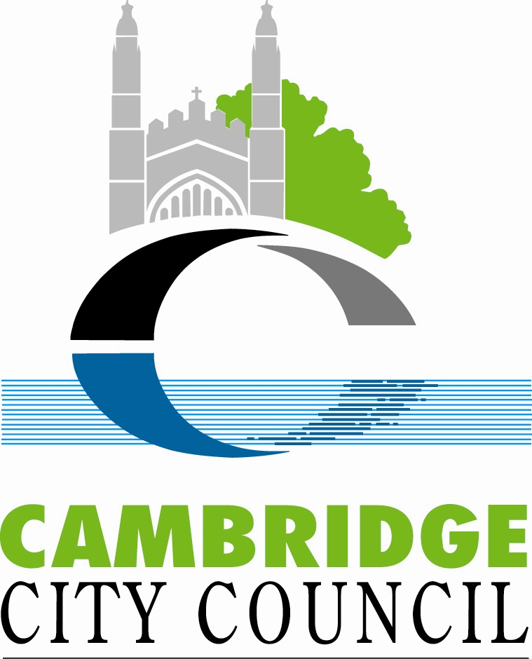
Cambridge City Council Equality Impact Assessment

Completing an Equality Impact Assessment will help you to think about what impact your strategy, policy, plan, project, contract or major change to your service may have on people that live in, work in or visit Cambridge, as well as on City Council staff.

The template is easy to use. You do not need to have specialist equalities knowledge to complete it. It asks you to make judgements based on evidence and experience. There are guidance notes on the intranet to help you. You can also get advice from David Kidston, Strategy and Partnerships Manager on 01223 457043 or email david.kidston@cambridge.gov.uk or from any member of the Joint Equalities Group.

- Title of strategy, policy, plan, project, contract or major change to your service:
Cambridge Local Plan 2014 - Draft Submission Plan

- What is the objective or purpose of your strategy, policy, plan, project, contract or major change to your service?
Set out the vision, objectives and plan for the development of Cambridge between 2011 and 2031. The Cambridge Local Plan 2014 will set out the planning framework to guide the future development of Cambridge.

- Who will be affected by this strategy, policy, plan, project, contract or major change to your service? (Please tick those that apply)
Residents

Visitors

Staff
A specific client group or groups (please state):
All people who live, work and visit Cambridge and the following groups:

SPECIFIC CONSULTATION BODIES
· Anglian Water
· Barton Parish Council
· British Gas
· Cambridge Crown Court
· Cambridge University Hospital (Addenbrooke’s)
· Cambridge Water Company
· Cambridgeshire Constabulary
· Cambridgeshire County Council
· Cambridgeshire Primary Care Trust
· Comberton Parish Council
· Coton Parish Council
· Cottenham Parish Council
· E.On Energy
· East Cambridgeshire District Council
· EDF Energy
· English Heritage
· Environment Agency
· Fen Ditton Parish Council
· Fenland District Council
· Fulbourn Parish Council
· Girton Parish Council
· Grantchester Parish Council
· Great Shelford Parish Council
· Hauxton Parish Council
· Highways Agency
· Histon and Impington Parish Councils
· Homes and Communities Agency
· Horningsea Parish Council
· Huntingdonshire District Council
· Madingley Parish Council
· Milton Parish Council
· N Power
· National Grid Transco
· Natural England
· Network Rail
· Norfolk Suffolk and Cambridgeshire Strategic Health Authority
· Npower Renewables
· Orchard Park Community Council
· Peterborough City Council
· Scottish and Southern Electric
· Scottish Power
· South Cambridgeshire District Council
· Teversham Parish Council

COUNCILLORS AND MPS
· 42 x City Councillors
· All County Councillors (City Wards)
· Julian Huppert MP
· Andrew Lansley MP

COMMUNITY ORGANISATIONS
· Age Concern Cambridgeshire
· Arthur Rank Hospice Charity
· Cambridge Citizens Advise Bureau
· Cambridge Ethnic Community Forum
· Cambridge Federation of Residents’ Associations
· Cambridge Interfaith Group
· Cambridgeshire Older Peoples Enterprise (COPE)
· Cambridgeshire Voluntary Sector Infrastructure Consortium (CVSIC)
· Disability Cambridgeshire
· East of England Faiths Council
· Encompass Network
· Irish Traveller Movement in Britain
· National Federation of Gypsy Liaison Groups
· The Church of England Ely Diocese
· The COVER Group
· The East Anglian Gypsy Council
· The GET Group
· Traveller Solidarity Network
· Work Advice Volunteering Education Training (WAVET)

ENVIRONMENTAL
· Cam Valley Forum
· Cambridge Carbon Footprint
· Cambridge Friends of the Earth
· Cambridge Past, Present and Future
· Cambridgeshire Local Access Forum
· Campaign to Protect Rural England
· Conservators of the River Cam
· Countryside Restoration Truse
· Hobson’s Conduit Trust
· National Trust
· RSPB Eastern England Office
· The Wildlife Trust
· Transition Cambridge

DEVELOPERS/AGENTS
· Artek Design House
· Barratt Eastern Counties
· Barton Wilmore
· Beacon Planning Ltd
· Bellway Homes
· Berkeley Homes
· Bidwells
· Bovis Homes Ltd
· Brookgate
· Capita Symonds
· Carter Jonas
· Chartered Institute of Architectural Technologist
· Cheffins
· Countryside Properties
· DPP
· Drivers Jonas
· Estate Management and Building Service, University of Cambridge
· Gallagher Estates
· Grosvenor
· Home Builders Federation
· Iceni Projects Ltd
· Januarys
· Liberty Property Trust
· RPS
· Savills
· Skanska UK Plc
· Taylor Vinters
· Taylor Woodrow Developments Ltd
· Terrance O’Rourke
· The Home Builders Federation
· The Howard Group of Companies
· The Universities Superannuation Scheme
· Unex

BUSINESSES
· ARM Holdings
· Cambridge Cleantech
· Cambridge Energy Forum
· Cambridge Hoteliers Association
· Cambridge Network
· Cambridgeshire Chambers of Commerce
· CRACA
· Creative Front
· Ely Cathedral Business Group
· Encompass Network
· Federation of Small Businesses
· Future Business
· Greater Cambridge Greater Peterborough Local Enterprise Partnership
· Love Cambridge
· Marshalls Group of Companies
· One Nucleus
· Redgate Software
· Royal Mail Group Ltd
· St John’s Innovation Centre

EDUCATION
· Anglia Ruskin University
· University of Cambridge
· All Colleges of the University of Cambridge
· The Bursars’ Committee
· Sixth Form Colleges
· Private Schools
· Cambridge Regional College
· Language Schools
· Secondary Schools in Cambridge

RESIDENTS ASSOCIATIONS
· All residents associations in Cambridge
· FeCRA (Federation of Cambridge Residents Associations)

OTHERS
· All who responded to the Issues and Options 1 and 2 Consultation
· Argyle Street Housing Cooperative
· BT Open Reach Newsites
· Cable and Wireless UK
· Cambridge Association of Architects
· Cambridge Cycling Campaign
· Cambridge Local Access Forum
· Cambridgeshire Campaign for Better Transport
· Cambridgeshire Fire and Rescue Service
· Design Council/CABE
· Fenners Lawn Residents Association Ltd
· Friends of Milton Road Library
· Local Strategic Partnership
· Mobile Operators Association
· Registered Social Landlords
· Shape East
· Sport England
· The Linchpin Project

- What type of strategy, policy, plan, project, contract or major change to your service is this? (Please tick)
New

Revised

Existing

- Responsible directorate and service
Directorate: Environment

Service: Planning

- Are other departments or partners involved in delivering this strategy, policy, plan, project, contract or major change to your service?
No

Yes (please give details):

See answer to question 3.

- Potential impact
Please list and explain how this strategy, policy, plan, project, contract or major change to your service could positively or negatively affect individuals from the following equalities groups.

When answering this question, please think about:
  - The results of relevant consultation that you or others have completed (for example with residents, people that work in or visit Cambridge, service users, staff or partner organisations).
  - Complaints information.
  - Performance information.
  - Information about people using your service (for example whether people from certain equalities groups use the service more or less than others).
  - Inspection results.
  - Comparisons with other organisations.
  - The implementation of your piece of work (don’t just assess what you think the impact will be after you have completed your work, but also think about what steps you might have to take to make sure that the implementation of your work does not negatively impact on people from a particular equality group).
  - The relevant premises involved.
  - Your communications.
  - National research (local information is not always available, particularly for some equalities groups, so use national research to provide evidence for your conclusions).

(a) Age (any group of people of a particular age, including younger and older people)
Yes, a positive impact
The plan seeks to meet objectively assessed needs for homes and jobs (including afforable homes) in Cambridge, this includes needs for an aging and young population.

The plan will deliver significant levels of afforable housing, this will benefit young people who cannot afford market housing.

The plan includes policies that seek to ensure all residential development is built to lifetime homes standards and on schemes of more than 20 dwellings, 5% of units are built to wheelchair housing design standard or can easily be adapted to meet this standard. The plan also seeks the provision of specialist housing according to need (e.g. care homes and sheltered housing.

The Local Plan will also plan for infrastructure such as childrens play areas, benefiting families with young children.

The document is availble for inspection in libraries for people who have difficulty getting into Council offices.

Potential issue – Although there is no evidence of any negative impact on young people, it is often difficult to engage with younger members of the community and officers may need to think about how young people can become involved in the policy making process.

- We have consulted various community organisations including Age Concern Cambridgeshire·and Cambridgeshire Older Peoples Enterprise (COPE).

(b) Disability (including people with a physical impairment, sensory impairment, learning disability, mental health problem or other condition which has an impact on their daily life)
Yes, a positive impact
- the plan includes policies that seek to ensure all residential development is built to lifetime homes standards and on schemes of more than 20 dwellings, 5% of units are built to wheelchair housing design standard or can easily be adapted to meet this standard. The plan also seeks the provision of specialist housing according to need (e.g. care homes and sheltered housing.)
- the plan includes a policy that seeks to improve accessibility for all (including those with mobility issues)
- the plan includes policies that require high quality, inclusive design for all new developments as part of a strategy to achieve an accessible and sustainable environment.
- in addition to this, access issues will also be addressed through Building Regulations.

The document is available in large print on request, and officers can talk through issues with people who have difficulty reading.

The document is availble for inspection in libraries for people who have difficulty getting into Council offices.

- We have consulted various community organisations including Disability Cambridgeshire.

(c) Gender
No, There is no evidence that the Local Plan will have differential impacts on people due to gender.

(d) Pregnancy and maternity
Yes, a positive impact
- the plan includes policies that seek to ensure all residential development is built to lifetime homes standards
- the plan includes a policy that seeks to improve accessibility for all (including those with mobility issues)
- the plan includes policies that require high quality, inclusive design for all new developments as part of a strategy to achieve an accessible and sustainable environment.
- in addition to this, access issues will also be addressed through Building Regulations.

The document is availble for inspection in libraries for people who have difficulty getting into Council offices.

(e) Transgender (including gender re-assignment)
No, There is no obvious evidence that the Local Plan will have differential impacts on people due to transgender (including gender re-assignment).

(f) Marriage and Civil Partnership
No, There is no evidence to show that this document will cause a differential impact on people due to marriage and civil partnership.

(g) Race or Ethnicity
No
- The document is written in plain English with minimal use of Jargon and the Council has a translations service available. There is a glossary included to explain technical terms used within the document.

- A policy sets out the criteria for the location of Gypsy and Traveller sites and will be used to guide the allocation of sites to meet the needs of the Gypsy and Traveller population.

- We have consulted various community organisations including Cambridge Ethnic Community Forum, ·Irish Traveller Movement in Britain, ·The East Anglian Gypsy Council and·Traveller Solidarity Network.

(h) Religion or Belief
Yes, a positive impact
- the plan includes policies that that deal with community facilites, including places of worship. This will ensure that any proposals for places of worship can be dealt with appropriately.

- We have consulted various community organisations including East of England Faiths Council and The Church of England Ely Diocese.

(i) Sexual Orientation
No, there is no evidence that the Local Plan will have differential impacts on people due to their sexual orientation.

(j) Other factor that may lead to inequality (please state):

- If you have any additional comments please add them here

- Conclusions and Next Steps
  - If you have not identified any negative impacts, please sign off this form.
  - If you have identified potential negative actions, you must complete the action plan at the end of this document to set out how you propose to mitigate the impact. If you do not feel that the potential negative impact can be mitigated, you must complete question 8 to explain why that is the case.
  - If there is insufficient evidence to say whether or not there is likely to be a negative impact, please complete the action plan setting out what additional information you need to gather to complete the assessment.
All completed Equality Impact Assessments must be emailed to David Kidston, Strategy and Partnerships Manager, who will arrange for it to be published on the City Council’s website. Email david.kidston@cambridge.gov.uk

- Sign off
Name and job title of assessment lead officer: Stephen Miles, Planning Policy & Economic Development Officer

Names and job titles of other assessment team members and people consulted:
Ariadne Henry, CDO (Engagement & Inclusion)

Date of completion: ⁵th July 2013

Date of next review of the assessment: On next plan review, should the plan change significantly prior to submission (January 2014) an update to the EQIA will be carried out.
Action Plan

Equality Impact Assessment title:

Date of completion: ¹⁹th April 2013

Equality Group | Age
Details of possible disadvantage or negative impact | Potential issue – Although there is no evidence of any negative impact on young people, it is often difficult to engage with younger members of the community and officers may need to think about how young people can become involved in the policy making process.
Action to be taken to address the disadvantage or negative impact | Ensure exhibitions are held outside of school / college times. Ensure consultation literature is is readable and attractive to all ages. Investigate anything further that can be done to attract interest from young people (noting that political engagment from young people is an issue across the country).  A pull out in Cambridge Matters.  Longer than normal consultation period to allow for the fact that it runs over the summer holidays.
Officer responsible for progressing the action | Stephen Miles
Date action to be completed by | Prior to consultation (July 2013).

Equality Group | Disability
Details of possible disadvantage or negative impact | No possible disadvantage or negative impact identified.
Action to be taken to address the disadvantage or negative impact | N/a.
Officer responsible for progressing the action | N/a.
Date action to be completed by | N/a.

Equality Group | Gender
Details of possible disadvantage or negative impact | No possible disadvantage or negative impact identified.
Action to be taken to address the disadvantage or negative impact | N/a.
Officer responsible for progressing the action | N/a.
Date action to be completed by | N/a.

Equality Group | Pregnancy and Maternity
Details of possible disadvantage or negative impact | No possible disadvantage or negative impact identified.
Action to be taken to address the disadvantage or negative impact | N/a.
Officer responsible for progressing the action | N/a.
Date action to be completed by | N/a.

Equality Group | Transgender
Details of possible disadvantage or negative impact | No possible disadvantage or negative impact identified.
Action to be taken to address the disadvantage or negative impact | N/a.
Officer responsible for progressing the action | N/a.
Date action to be completed by | N/a.

Equality Group | Marriage and Civil Partnership
Details of possible disadvantage or negative impact | No possible disadvantage or negative impact identified.
Action to be taken to address the disadvantage or negative impact | N/a.
Officer responsible for progressing the action | N/a.
Date action to be completed by | N/a.

Equality Group | Race or Ethnicity
Details of possible disadvantage or negative impact | No possible disadvantage or negative impact identified.
Action to be taken to address the disadvantage or negative impact | N/a.
Officer responsible for progressing the action | N/a.
Date action to be completed by | N/a.

Equality Group | Religion or Belief
Details of possible disadvantage or negative impact | No possible disadvantage or negative impact identified.
Action to be taken to address the disadvantage or negative impact | N/a.
Officer responsible for progressing the action | N/a.
Date action to be completed by | N/a.

Equality Group | Sexual Orientation
Details of possible disadvantage or negative impact | No possible disadvantage or negative impact identified.
Action to be taken to address the disadvantage or negative impact | N/a.
Officer responsible for progressing the action | N/a.
Date action to be completed by | N/a.

Other factors that may lead to inequality
Details of possible disadvantage or negative impact | No possible disadvantage or negative impact identified.
Action to be taken to address the disadvantage or negative impact | N/a.
Officer responsible for progressing the action | N/a.
Date action to be completed by | N/a.

